**NEW ONLINE SPANISH COURSES FOR FOREIGN NATIONALS**



**FEATURES OF THE ONLINE COURSE**:

* The course lasts approximately 8 months from the start date.
* 500 places are available.
* Level and progress tests.
* You will receive an email accepting you on the course with information and access codes.
* You can access the system in any one of the 20 interface languages available.

**Advantages:**

* You will be able to access the system wherever you are, 24 hours a day, 7 days a week.
* We recommend you access it from a PC. Mobile phones and tablets may be used although not all the features will be available.
* The course is adapted to each student's own level. You CANNOT work off-line.
* There is a tutorial (video-virtual) for getting to know the system (in Spanish, English, French, German and Italian).
* 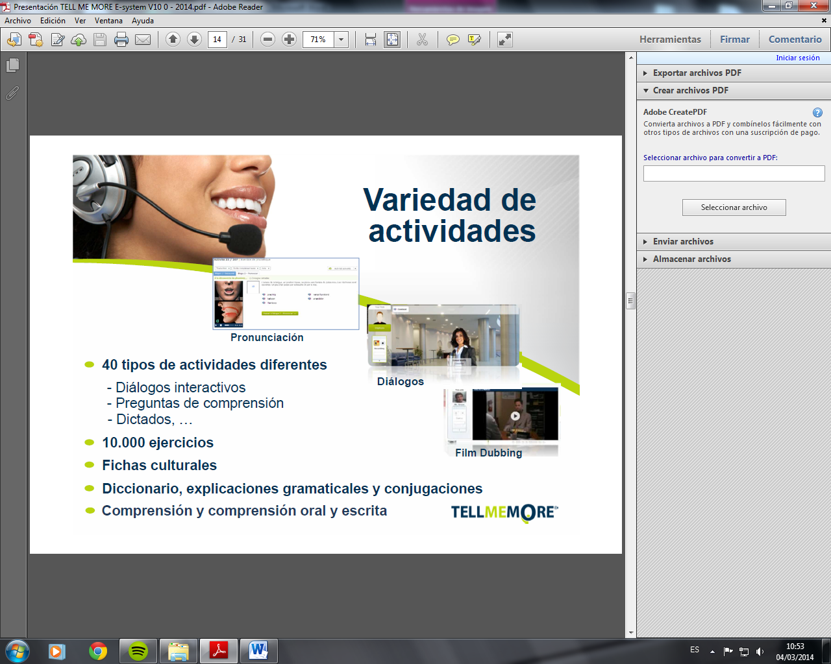You can personalise the course according to your interests and your progress.
* Technical assistance is provided in Spanish and English via email.

**ADMISSION REQUIREMENTS**:

- You must be a Foreign National and be **registered** ("empadronado") with a town council in the province of Alicante. **Along with your registration form you must submit a copy of the local registration certificate ("certificado de empadronamiento") issued by your Town Council** (only certificates dated from January 2016 onwards will be accepted).

- You must have access to a computer with the technical requirements listed.

- You must have headphones or loudspeakers plus a microphone.

- You will not be accepted onto the course unless you complete all fields of the registration form and supply the required documentation ("empadronamiento").

**Because of the limited number of places available, to stay on the course you must:**

- **Do the level test during the first week after receiving the access codes. If you do not, you will be REMOVED from the course without prior warning.**

**\***We advise you to check your spam inbox in case our emails or emails from the company supplying the course go astray. To prevent your computer from treating our emails as spam, please add the [noreply@rosettastone.com](mailto:noreply@rosettastone.com) email address to your contacts list.

- **During the first month of the course, students are required to complete at least 10 hours of coursework online.** Any students not reaching this minimum **will be REMOVED from the course without the need for prior warning**.

- **To obtain the course certificate students must complete at least 50 hours of coursework** over the 8 months course duration.

**REGISTRATION**:

- To register, please **send the registration form and "empadronamiento" certificate** by e-mail to: [ciudadanosextranjeros@diputacionalicante.es](mailto:ciudadanosextranjeros@diputacionalicante.es)

- Registration is **free** and is done on a first-come first-served basis as registration forms are received.

**REGISTRATION PERIOD: open until all 500 available places have been allocated.**

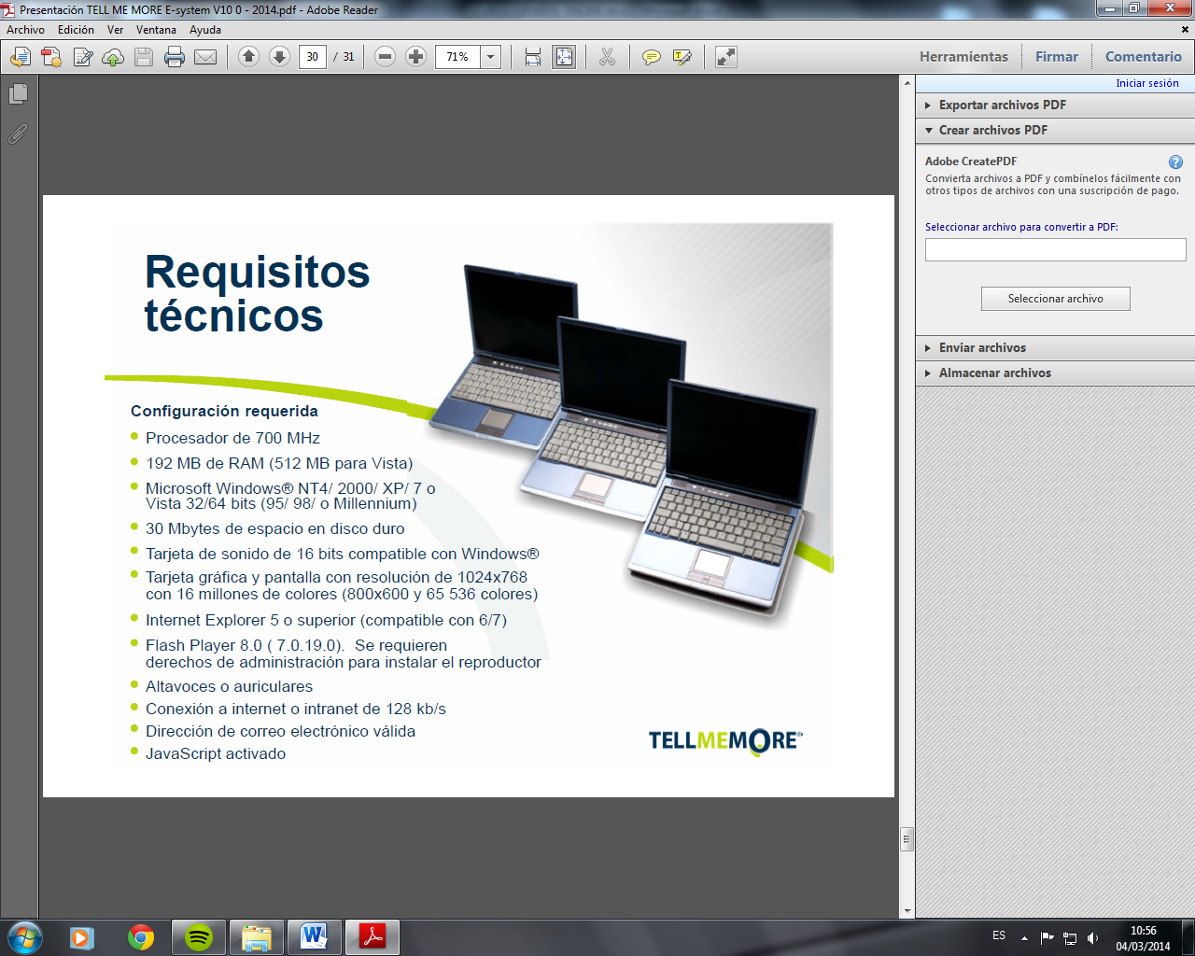

**CONFIGURATION REQUIRED**

***To use the Advantage system you must have the following:***

***· The ability to download SWF files for storage in the browser cache at execution time.***

***· Flash Video via IP***

Computer:

• Minimum 1.5 GHz processor

• 512 MB RAM

• 50 MB free space on the hard disk

• 1024x768 graphics resolution, 16 million colours and above

• Sound card and loudspeakers. USB connection headphones with microphone or with two jacks.

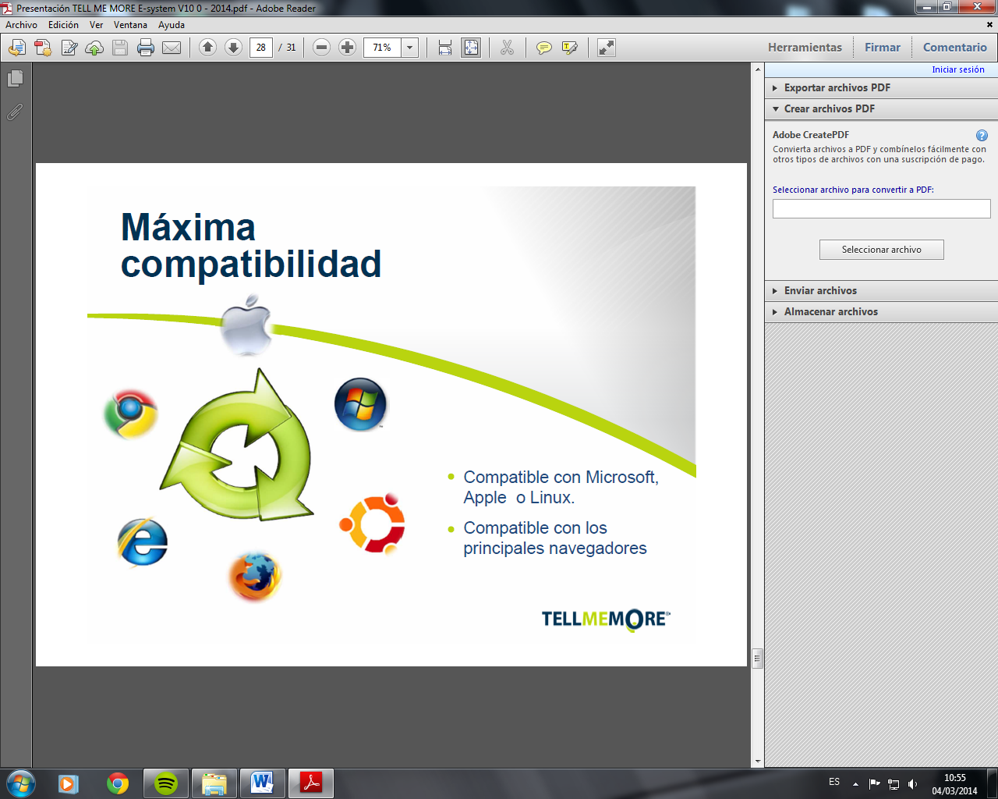Operating system:

• Windows Vista SP2, 7, 8 and 10, Mac (Intel) OS X 10.7, 10.8, 10.9 and 10.10

• **LIMITED ACCESS ON** Tablets and mobile phones: CPU speed on tablets and mobiles (minimum) of 500MHz. iOS 6.0 or later — Rosetta Stone® Vocabulary application for mobile devices.

Browser:

• Browsers—Internet Explorer 7/8/9/10/11, Edge Browser 12, Safari 5/6/7 and the latest versions of

Chrome and Firefox.

Note: Javascript must be activated in the browser.

Flash Player

• Flash – the latest version is advisable (Flash 13 is the minimum version)

Note: To install Flash you need to have system administrator rights.

Network/Internet connection

• Broadband connection–minimum 192 kbps download and upload speed; you can test your bandwidth speed at: http://launch.RosettaStone.com/speedtest/

Email address

WARNING: your computer will communicate with the domains listed below. Rosetta Stone adds services as Advantage functions are expanded.

• *.RosettaStone.com

• *.RosettaStoneenterprise.com

• *.tellmemore.com

• *.tellmemorecampus.com

• *.tellmemorepro.com

• *.tellmemore.cn

• *.tellmemorecampus.cn

• *.rosettastone.cn

• *.tellmemorepro.cn

• *.adobe.com

• *.zoomerang.com